Name: ___________________________

Body Biography
Rubric

 | Possible Points | Points Earned
Who or what you love the most is on your heart | 5
List 5 goals (short or long term goals) on your shirt | 10
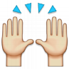  List 2 things that motivate you (one on each hand) | 10
Name a weakness on each foot | 10
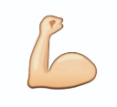  Name a hobby you have on each arm | 10
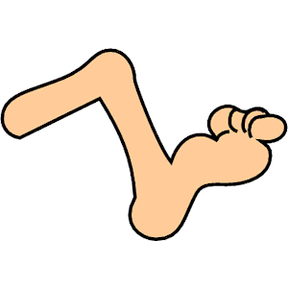  Name a place you love to go on each leg | 10
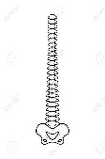  On your backbone, write an acrostic poem (Using each letter  of your first name, write an adjective that describes you or  your personality.) | 20
Draw & color your features and favorite outfit. Cut out your  body biography. | 10
Be sure your work is neat, clear and easy to read | 10
Name, date, & class period included on the back | 5

